**Experiment 10: Simple application using Ajax**

**Aim:** To make a simple application using Ajax.

**Implementation:**

**Output:**

**https://kuldeep1628.github.io/ajax-demo/**

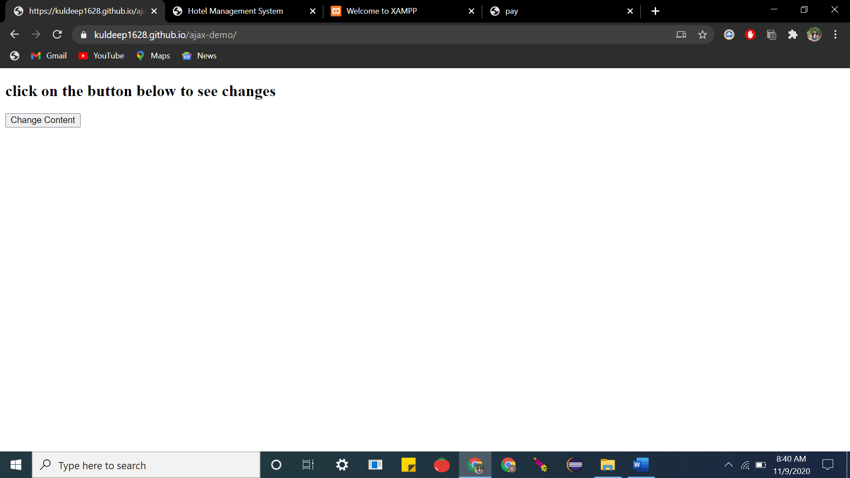

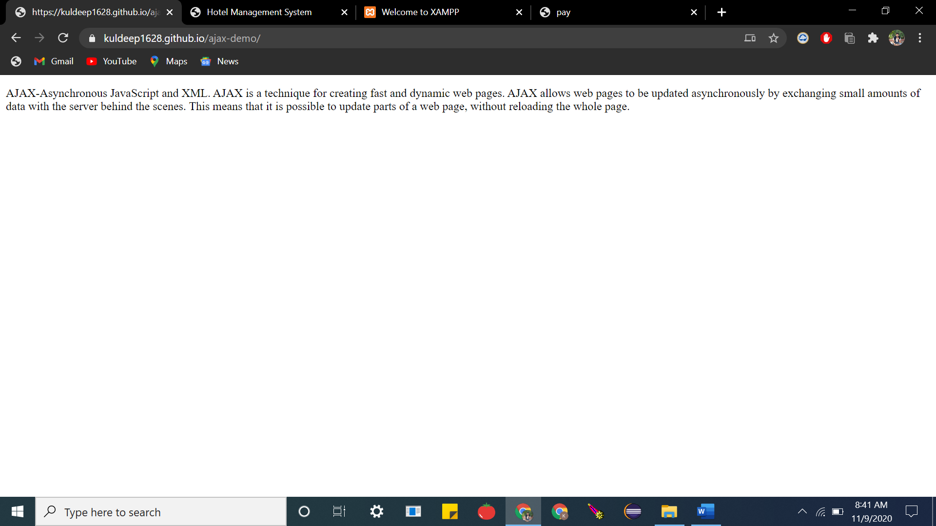

**Code:**

**INDEX.html**

|  |
| --- |
| <!DOCTYPE html> |
|  | <html> |
|  | <body> |
|  |  |
|  | <div id="demo"> |
|  | <h2>click on the button below to see changes</h2> |
|  | <button type="button" onclick="loadDoc()">Change Content</button> |
|  | </div> |
|  |  |
|  | <script> |
|  | function loadDoc() { |
|  | var xhttp = new XMLHttpRequest(); |
|  | xhttp.onreadystatechange = function() { |
|  | if (this.readyState == 4 && this.status == 200) { |
|  | document.getElementById("demo").innerHTML = |
|  | this.responseText; |
|  | } |
|  | }; |
|  | xhttp.open("GET", "ajax.html", true); |
|  | xhttp.send(); |
|  | } |
|  | </script> |
|  |  |
|  | </body> |
|  | </html> |

**AJAX.html**

|  |
| --- |
| <!DOCTYPE html> |
|  | <html> |
|  | <body> |
|  |  |
|  | <p>AJAX-Asynchronous JavaScript and XML. AJAX is a technique for creating fast and dynamic web pages. AJAX allows web pages to be updated asynchronously by exchanging small amounts of data with the server behind the scenes. This means that it is possible to update parts of a web page, without reloading the whole page. |
|  | </p> |
|  |  |
|  | </body> |
|  | </html> |

**Result:**The experiment was successfully completed.